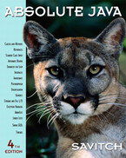 COSC 1320
Name: _________________ Terminal #__

Estimated Hours 1
Actual Hours

TA (Textual Analysis) for UML MVC CLASS Diagram MODEL
Programming Assignment 2:
(20 points.)
(due date found in the COSC 1320 BB Calendar!)
You must use Microsoft WORD program. Insert the TEMPLATEs for Actors and Use Cases in this Requirements Document.

Please have Step 1, 2, 3, 4, and 5 in this order.
Requirements Analysis: Construct the UML MVC CLASS Diagram MODEL

GUI PIZZA APPLICATION SWING
GuiView
MenuController
Write a GUI application program, to create a menu for a pizza shop. Use check boxes, radio buttons, and a JButton to allow a customer to make selections and process their order. Use a text area to display the customer’s order and the amount due. A sample menu and a customer’s order is shown in Figure below:
OrderModel: 1 – addTopping(): Make & Selections
OrderModel
OrderModel: 2 – selectSize(): Make & Selections
OrderModel: 3 – selectCrust(): Make & Selections
OrderModel: 4 – processOrder(): Process & Order
OrderModel: 5 – displayOrder(): Display & Order
GuiView: 1 – initGui()
MenuController: 1 – main()
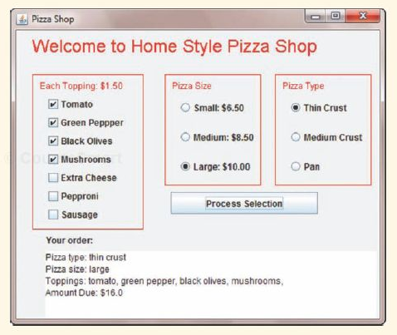
Toppings: 1 - Tomato
Toppings: 2 - gPepper
Pizza
Toppings: 6 - pepperoni
Toppings: 7 - sausage
Toppings: 5 - eCheese
Toppings: 4 - mushroom
Toppings: 3 - bOlives
Toppings
Pizza: 1 - size
Pizza: 2 – type
GuiView
- order: OrderModel

+ initGui(): void
Toppings
- tomato: boolean //1
- gPepper: boolean //2
- bOlives: boolean //3
- mushroom: boolean //4
- eCheese: boolean //5
- pepperoni: boolean //6
- sausage: boolean //7
Pizza
MenuController
- view: GuiView
+ main(): void
OrderModel
“has a”
“uses”
“uses”
“uses”

- totalCost: double
- toppingPrice: double
- pizza: Pizza

+ addTopping(event):void
+ selectSize(event):void
+ selectCrust(event):void
+ processOrder():void
+ displayOrder():void

- size: String //1
- type: String //2
- toppings: Toppings //3
- smPrice: double
- medPrice: double
- lgPrice: double

//accessors
+ getTomato()
+ getGpepper()
+ getBolives()
+ getMushrooms()
+ getCheese()
+ getPepperoni()
+ getSausage()
//mutators
+ setTomato()
+ setGpepper()
+ setBolives()
+ setMushrooms()
+ setCheese()
+ setPepperoni()
+ setSausage()

+ getSize():String
+ getType():String
+ setSize(String):void
+ setType(String):void

GuiView
- order: OrderModel

public void initGui()
{
This initialize gui method will create the entire user interface, the container and all objects within it using JFrame. It will call OrderModel when an event happens to execute the correct response to the event.
}

OrderModel
- totalCost: double
- toppingPrice: double
- pizza: Pizza
public void addTopping(event)
{
Uses the event that is passed in the argument to execute a change in the Boolean value stored within pizza.toppings
}

public void selectSize(event)
{
Uses the event that is passed in the argument to change the pizza.size and adjust totalCost accordingly.
}

public void selectCrust(event)
{
Uses the event that is passed in the argument to change the pizza.type
}

public void processOrder()
{
Uses the pizza.toppings Booleans to evaluate how much the pizza costs and then puts that into totalCost variable.
}

public void displayOrder()
{
Displays all information including type, size, toppings, and total cost of the pizza.
}

Pizza
- size: String
- type: String
- toppings: Toppings
- smPrice: double
- medPrice: double
- lgPrice: double

public String getSize() {Return size;}

public void getType() {Return type;}

public void setSize(String) {Size = string;}

public void setType(String) {Type = string;}

Toppings
- tomato: boolean //1
- gPepper: boolean //2
- bOlives: boolean //3
- mushroom: boolean //4
- eCheese: boolean //5
- pepperoni: boolean //6
- sausage: boolean //7
public boolean getTomato() {Return tomato;}

public boolean getGpepper() {Return gPepper;}

public boolean getBolives() {Return bOlives;}

public boolean getMushroom() {return mushrooms;}

public boolean getCheese() {Return eCheese;}

public boolean getPepperoni() {Return pepperoni;}

public boolean getSausage() {Return sausage;}

public void setTomato(bool) {tomato = bool;}

public void setGpepper(bool) {gPepper = bool;}

public void setBolives(bool) {bOlives = bool;}

public void setMushroom(bool) {mushrooms = bool;}

public void setCheese(bool) {eCheese = bool;}

public void setPepperoni(bool) {pepperoni = bool;}

public boolean getSausage() {Return sausage;}

